EX. NO 5 Write a Servlet to demonstrate the difference
between HTTP GET and POST methods by
creating a form and handling requests accordingly

AIM:
To demonstrate the difference between the HTTP GET and POST methods by creating a
form in an HTML page and handling the form submissions using two different HTTP
methods in a Java Servlet.
ALGORITHM:
1. Input:
• The user fills out a web form with their name and email.
• The form will use both GET and POST methods for data submission.

2. Steps for Creating and Handling the HTTP GET and POST Requests:
1. Create an HTML Form:
o Design an HTML form with two input fields: one for the name and one for the
email.
o Create two buttons to allow the user to submit the form using GET or POST
methods.
o Use the action attribute to define the Servlet URL and specify the form
method (either GET or POST).

2. Create the Servlet to Handle GET and POST Requests:
o Write a Java Servlet class that will handle both GET and POST requests.
o The servlet will have two methods:
▪ doGet() to handle the GET requests.
▪ doPost() to handle the POST requests.
o In both methods, retrieve the form data using request.getParameter().
o In the doGet() method, process and display the data in the URL.
o In the doPost() method, process and display the data in the HTTP request
body.

3. Handle GET Requests in the Servlet:
o In the doGet() method, use request.getParameter() to retrieve the name and
email submitted via GET.
o Output the data as a response, including the name and email in the URL
(visible to the user).

4. Handle POST Requests in the Servlet:
o In the doPost() method, use request.getParameter() to retrieve the name and
email submitted via POST.
o Output the data as a response, displaying the name and email without
exposing them in the URL (more secure).

5. Return the Output:
o The Servlet should return an HTML page displaying the name and email
entered by the user.
o For the GET method, the output should be visible in the URL.
o For the POST method, the output should be visible in the response body, not
the URL.

6. Deploy and Test the Servlet:
o Compile the Servlet class and deploy it to a Servlet container (like Apache
Tomcat).
o Test the form using GET and POST methods to see the difference in data
submission.
7. Observe and Compare GET and POST Results:
o Test the GET method: The form data is sent in the URL.
o Test the POST method: The form data is sent in the HTTP request body, not
visible in the URL.
code:
<!-- index.html -->

<!DOCTYPE html>
<html>
<head>
<title>GET and POST Demo</title>
</head>
<body>

<h2>HTTP GET Method</h2>

<form action="MethodServlet" method="get">

Name:
<input type="text" name="username">

<input type="submit" value="Send GET">

</form>

<br><br>

<h2>HTTP POST Method</h2>

<form action="MethodServlet" method="post">

Name:
<input type="text" name="username">

<input type="submit" value="Send POST">

</form>

</body>
</html>

Output:
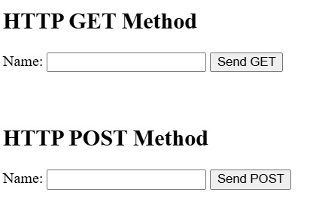

RESULT:
A Servlet is created to demonstrate the difference between HTTP GET and POST methods by
creating a form and handling requests accordingly.

